D. XOR-gun
time limit per test
2 seconds
memory limit per test
256 megabytes
input
standard input
output
standard output
Arkady owns a non-decreasing array a1,a2,…,ana1,a2,…,an. You are jealous of its beauty and want to destroy this property. You have a so-called XOR-gun that you can use one or more times.
In one step you can select two consecutive elements of the array, let's say xx and yy, remove them from the array and insert the integer x⊕yx⊕y on their place, where ⊕⊕ denotes the bitwise XOR operation. Note that the length of the array decreases by one after the operation. You can't perform this operation when the length of the array reaches one.
For example, if the array is [2,5,6,8][2,5,6,8], you can select 55 and 66 and replace them with 5⊕6=35⊕6=3. The array becomes [2,3,8][2,3,8].
You want the array no longer be non-decreasing. What is the minimum number of steps needed? If the array stays non-decreasing no matter what you do, print −1−1.
Input
The first line contains a single integer nn (2≤n≤1052≤n≤105) — the initial length of the array.
The second line contains nn integers a1,a2,…,ana1,a2,…,an (1≤ai≤1091≤ai≤109) — the elements of the array. It is guaranteed that ai≤ai+1ai≤ai+1 for all 1≤i<n1≤i<n.
Output
Print a single integer — the minimum number of steps needed. If there is no solution, print −1−1.
Examples
input
Copy
4
2 5 6 8
output
Copy
1
input
Copy
3
1 2 3
output
Copy
-1
input
Copy
5
1 2 4 6 20
output
Copy
2
Note
In the first example you can select 22 and 55 and the array becomes [7,6,8][7,6,8].
In the second example you can only obtain arrays [1,1][1,1], [3,3][3,3] and [0][0] which are all non-decreasing.
In the third example you can select 11 and 22 and the array becomes [3,4,6,20][3,4,6,20]. Then you can, for example, select 33 and 44 and the array becomes [7,6,20][7,6,20], which is no longer non-decreasing.
First let's compute array b1,b2,…,bnb1,b2,…,bn, where bibi is the index of the highest bit equal to 11 in the binary notation of aiai. The statement says bi≤bi+1bi≤bi+1. These values can be computed by dividing the given numbers by 22 until they are zero.
Note that if for a given ii the equality bi−1=bi=bi+1=tbi−1=bi=bi+1=t holds, then we can apply an operation to aiai and ai+1ai+1, and the resulting integer is smaller than ai−1ai−1. Indeed, in ai−1ai−1 the highest bit set is tt, but in ai⊕ai+1ai⊕ai+1 the tt-th and higher bits are zeros. That means if there is such an ii (it is easy to check in a single linear pass), then the answer is 11.
Now note that if there is no such ii, then the size of the array nn is not bigger than 2⋅(⌊log2109⌋+1)=602⋅(⌊log2⁡109⌋+1)=60! Indeed, there are no more than two integers with the same highest bit set. It is much easier to solve the problem in such constraints.
Consider some solution. In the final array, let's denote it as cc, there is ii such that ci>ci+1ci>ci+1. Note that each element of the final array is equal to XOR of some subsegment of the initial array, and each element of the initial array belongs to exactly one such subsegment. Let this subsegment for cici be al,al+1,…,amal,al+1,…,am, and for ci+1ci+1 be am+1,am+2,…,aram+1,am+2,…,ar. Then it's clear that to find an optimal solution it is enough to loop through all possible values of ll, mm, and rr and check whether XOR of all elements of the left subsegment is larger than XOR of all elements of the right subsegment. If this inequality holds, update answer with value r−l−1r−l−1. The complexity of this part is O(n3)O(n3) or O(n4)O(n4) depending on implementation.

然后异或有个结论就是
区间 j+1~i的异或和=sum[j]^sum[i]
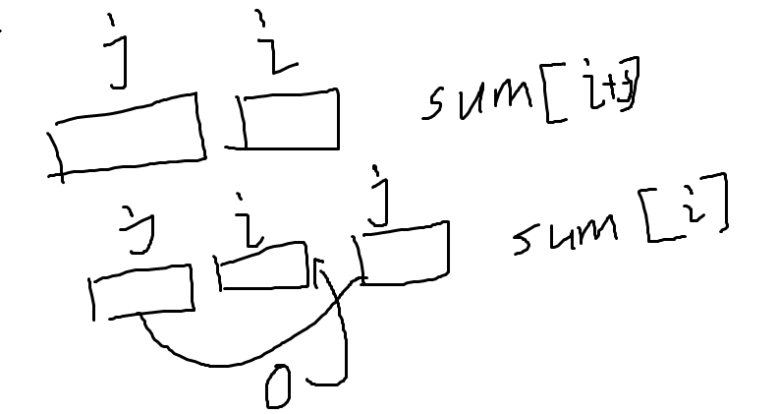
#include<bits/stdc++.h>
#define ll long long
using namespace std;
const int N=1e5+10;
int a[N];
int sum[N];
int main()
{
int n;
scanf("%d",&n);
for(int i=1;i<=n;i++)
{
scanf("%d",&a[i]);
}
for(int i=1;i<=n;i++)
{
sum[i]=sum[i-1]^a[i];
}
if(n>60) {printf("1\n");return 0;}
int ans=1000000;
for(int i=1;i<=n;i++)
{
for(int j=0;j<i;j++)//from j+1 to i to k
{
for(int k=i+1;k<=n;k++)
{
if((sum[j]^sum[i])>(sum[i]^sum[k]))
{
ans=min(ans,k-j-2);
}
}
}
}
if(ans==1e6) ans=-1;
cout<<ans;
return 0;
}

